
Import of Warehouse Inventory Data from csv-file

© Eagle Datamation International Pty Ltd
• Level 2, 184 Bourke Road Alexandria NSW Australia
• Phone 61 2 9025 1100 • Fax 61 2 9025 1199 • training@edi.com.au

Table of Contents

1 Introduction 1
1.1 Important Remarks 1
1.2 Importing Organisation Data 1
2 File Specification 5
2.1 Generic Attributes of csv-Data Import Files 5
2.2 File Specification 5

Introduction

ediEnterprise has the capability to import Warehouse Inventory data from a csv-file. This document describes the standard file format for import of Warehouse Inventory data.
The data can be imported into ediEnterprise using the option Operations → Inwards Goods → Export/Import → Import From Excel (.csv).

Important Remarks

It is essential that you strictly follow the file specification described in this document. If you would like to import Organisation data in a different file format, customer-specific programming will be necessary. This would be chargeable programming and require a quotation.

- Each Organisation in the csv-file will be added as a new record in ediEnterprise. The data import procedure will not merge any Organisations.

- Provide your current Organisation code in the csv-file, if possible. It will be then be stored on the Organisation → Config tab → Cntry <System Country>, Type “LSC = Legacy System Code” for further reference.

- If you want to bring across A/R and/or A/P Balances for the Organisations that you import from csv-file, provide an Organisation code. Otherwise the system cannot link the Balances to the Organisations and will not import the Balances.
- If Organisation data has been imported and you try to re-import the same Organisation data, the system will not load it. (N.B.: The system will verify whether an Organisation exists in ediEnterprise that has the same “Legacy System Code” = “LSC”.) The system will display all Organisations that have been excluded from the data import for this reason. The operator may print the list.
If errors occur, the whole data import is aborted.

Importing Organisation Data

Operations → Inwards Goods → Export/Import → Import From Excel (.csv) to import Warehouse Inventory data from a csv-file as per file specification below.

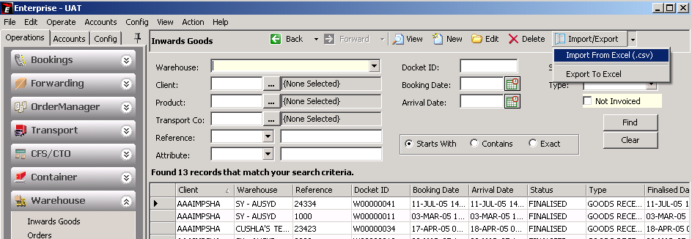

??? The system will prompt you:
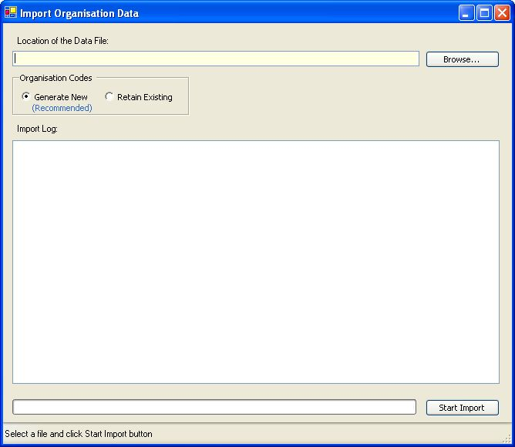

Option | Description
Location of the Data File | Enter the data-directory and file name.
Organisation Codes:
Generate New | - Recommended option -  Tick to create new Organisation codes using the ediEnterprise coding algorithm:  - first 3 characters of the first word and  - first 3 of the second word and  - last 3 characters of the Organisation’s Port code  For example “American Express International Pty Ltd” in AUSYD would be coded as “AMEEXPSYD”.
Retain Existing | Tick to keep the Organisation Codes provided in the file.  N.B. Organisation Codes for new Organisations entered in ediEnterprise will be coded as per new coding structure and will therefore differ.

Press the [Start Import] button to import the Organisation data.

System Prompt after pressing the <Start Import> button:
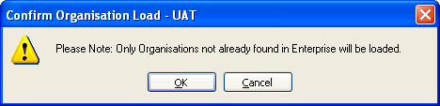

System Logging, if the File Header is incorrect:
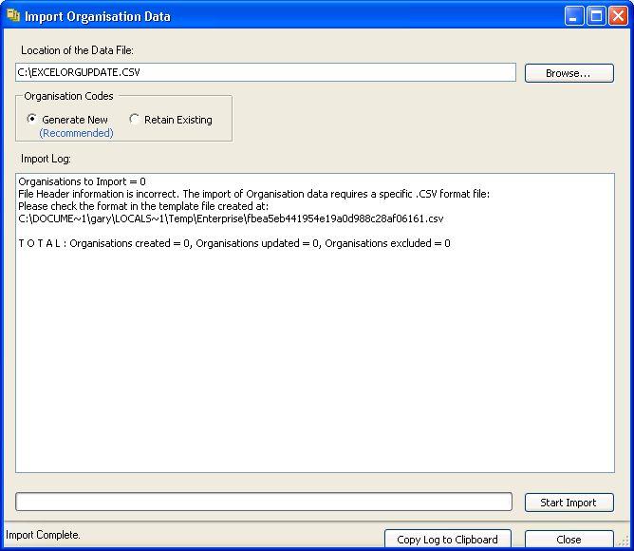
Open the sample csv-file created by the system. It shows the required file format and column headers.

System Logging showing errors that may occur:
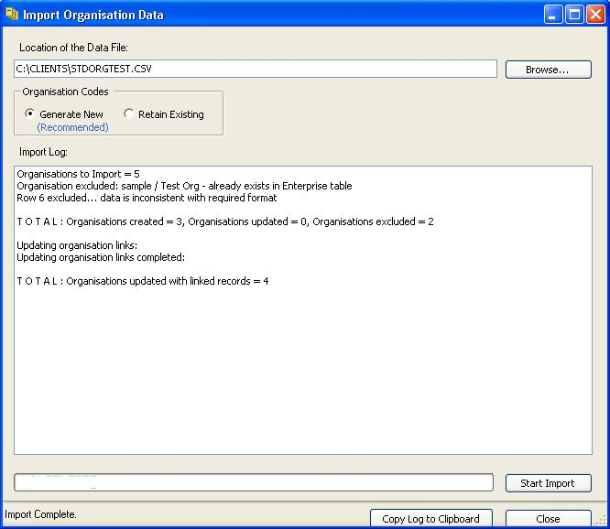

File Specification

Generic Attributes of csv-Data Import Files

The following applies to the standard ediEnterprise data import files in csv-file format:
- The file format is csv-file.
- The first line of the file must be the header line. It must contain the headers in exactly the same spelling as per file specification below. Otherwise the data will not be imported.
- It is essential that you provide all columns in the order as listed in the file specification. Do not add any additional columns or omit any columns. Otherwise the data will not import.
- Leave non-mandatory fields blank, if you cannot provide the data.
- Date fields are 8 characters in the form YYYYMMDD. No separators are allowed.
- Boolean fields are character “Y” = True or character “N” = False.
A blank boolean field is interpreted as “N”.
The system validates the header of each column to determine whether the file structure matches the standard. If the number of columns differs or the column headers are spelt differently, the data will not import.

If you haven’t already received a sample file, you are welcome to contact edi and request one.

File Specification
Legend:
Col Column
Type A = Alphanumeric
N = Numeric
B = Boolean
M = Mandatory
C = Conditional

Col | Header | Type | M | Remarks
1 | CustomsEntryNo | 30 A |  | Bonded Inventory: Customs Entry No.  Free-Store Inventory: Leave blank.  This field is used to identify whether or not the Products are in the Bonded Warehouse.
2 | ClientCode | 12 A | M | Bonded Inventory: Customs Client Code (Organisation → Config tab → Cntry <System Country>, Type “CCD”).  Free-Store Inventory: ediEnterprise Organisation Code.  If a code is provided that is not set up in ediEnterprise, the data import is aborted.
3 | Warehouse | 50 A | C | Bonded Inventory: Customs Client Code (Organisation → Config tab → Cntry <System Country>, Type “CCP = Customs Controlled Premises”).  Free-Store Inventory: Warehouse Name.  If a code or Warehouse Name is provided that is not set up in ediEnterprise, the data import is aborted.
4 | Reference | 35 A |  | Defaults to system generated Docket ID, if left blank.
5 | ArrivalDate | Date |  | Defaults to today’s date, if left blank.
6 | ProductCode | 30 A | M | The Product Code needs to be set up in ediEnterprise and be linked to the Client Code provided above.
7 | Quantity | 9.4 N | M
8 | QuantityUQ | 3 A |  | Defaults to Product’s Stock Keeping Unit, if left blank.
9 | Pallets | 9.0 N
10 | Location | 30 A |  | A location will automatically be allocated, if left blank. Amend after data import if needed.
11 | Attribute1 | 25 A | C | Mandatory, if Product is set to use Attribute1.
12 | Attribute2 | 25 A | C | Mandatory, if Product is set to use Attribute2.
13 | Attribute3 | 25 A | C | Mandatory, if Product is set to use Attribute3.
14 | ExpiryDate | Date | C | Mandatory, if Product is set to use Expiry Dates.
16 | PackingDate | Date | C | Mandatory, if Product is set to use Packing Dates
17 | CustomsEntryLineNo | 4.0 N | C | Bonded Inventory: Mandatory.  Free-Store Inventory: Leave blank.
18 | CustomsEntryDate | Date | C | Defaults to “ArrivalDate”, if left blank. If Arrival Date is also left blank, defaults to today’s date.
19 | CustomsAddInfo | 250 A |  | Bonded Inventory: Provide, if applicable.  Free-Store Inventory: Leave blank.
20 | CustomsQty | 9.4 N | C | Bonded Inventory: Defaults to “Quantity”, if left blank.  Free-Store Inventory: Leave blank.
21 | CustomsUQ | 3 A |  | Defaults to “QuantityUQ”, if left blank.
22 | CtryOfOrigin | 2 A |  | Bonded Inventory: Provide.  Free-Store Inventory: Leave blank.
23 | ValueForDuty | 9.4 N | C | Mandatory, if Customs Entry Number is provided.
24 | BondedWhsQty | 9.4 N |  | Relevant for South African sites only.  Other sites: Leave blank.
25 | BondedWhsUQ | 3 A |  | Relevent for South African sites only:  Defaults to Product’s Stock Keeping Unit, if left blank.  Other sites: Leave blank.
26 | TILV | 9.4 N |  | Bonded Inventory: TILV Amount.  Free-Store Inventory: Leave blank.

